|  |  |
| --- | --- |
| Subject: Skill base Lab Course:  Cloud Computing | Course ID: CSL605 |
| Semester: VI | Course: AI & DS |
| Laboratory: 101 | Name of teacher: Prof. Devita Ghanekar |
| Name of Student: Ayush Gupta | Roll No: VU2S2324001 |

**EXPERIMENT NO. 3**

**Aim:**  
To study and Implement Platform as a Service using AWS Elastic Beanstalk.

**Hardware:**

* **Device Name:** computer-ThinkCentre
* **Hardware Model:** Lenovo ThinkCentre neo 50t Gen 3
* **Memory:** 8.0 Gib
* **Processor:** 12th Gen Intel® Core™ i5-12400 × 12
* **Disk Capacity:** 256.1 GB

**Software:**

* **Operating System:** LINUX
* **Amazon AWS**

**Theory:**  
The objective of this experimrnt is to demonstrate the steps to deploy Web applications or Web services written in different languages on AWS Elastic Beanstalk/ Microsoft Azure App Service.

An Amazon EC2 instance is a virtual server in Amazon's Elastic Compute Cloud (EC2) for running applications on the Amazon Web Services (AWS) infrastructure.

Amazon Elastic Compute Cloud (Amazon EC2) offers the broadest and deepest compute platform, with over 600 instances and choice of the latest processor, storage, networking, operating system, and purchase model to help you best match the needs of your workload.

We are the first major cloud provider that supports Intel, AMD, and Arm processors, the only cloud with on-demand EC2 Mac instances, and the only cloud with 400 Gbps Ethernet networking.

It offers the best price performance for machine learning training, as well as the lowest cost per inference instances in the cloud. More SAP, high performance computing (HPC), ML, and Windows workloads run on AWS than any other cloud.

**Algorithm:**

**Step1:** Login to AWS console and go to Elastic Beanstalk

**Step 2:** Click on Create Application

**Step 3:** Write Application information : Name, Tag,Platform etc.

**Step 4:** In Application Code: select sample application and then Click on button

Create Application This will take a few minutes.

**Step 5:** Click on Environments -> Check the health of Environment wait till it becomes ‘OK

**Step 6:** Click the URL

**Step 7:** To Delete the application and Environment

(Select it and in Action -Delete/Terminate: give conformation)

**Conclusion:**  
Thus, in this practical we have studied and implemented Platform as a service (PaaS) using AWS Beanstalk.

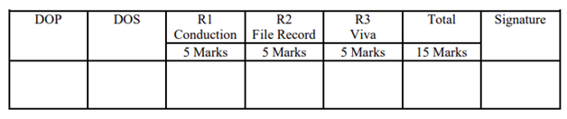

**Screenshots:**

